**\*Design Patterns and Principles\***

Exercise 1: Implementing the Singleton Pattern

CODE:

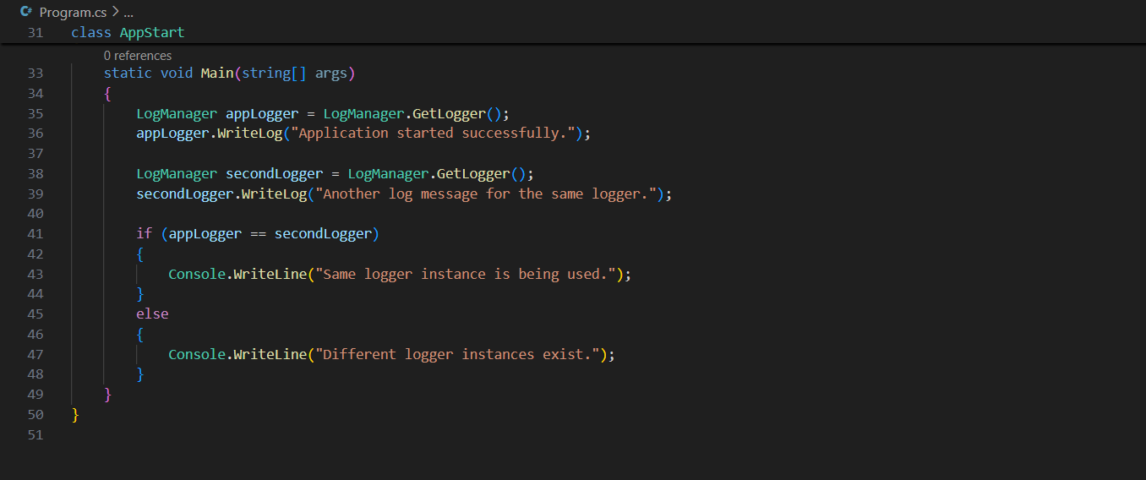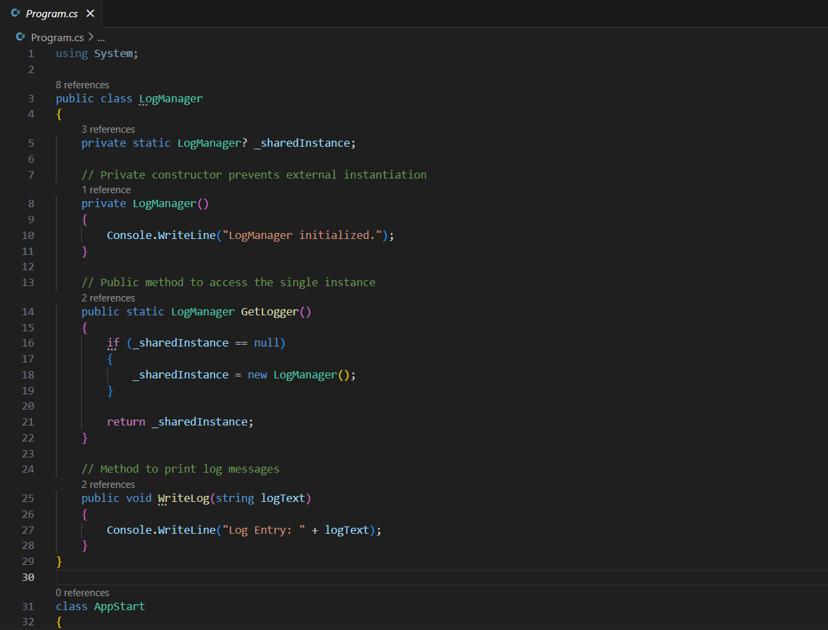

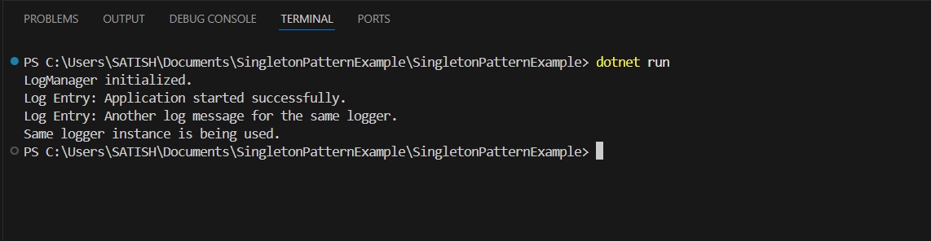OUTPUT:

Exercise 2: Implementing the Factory Method Pattern

CODE:

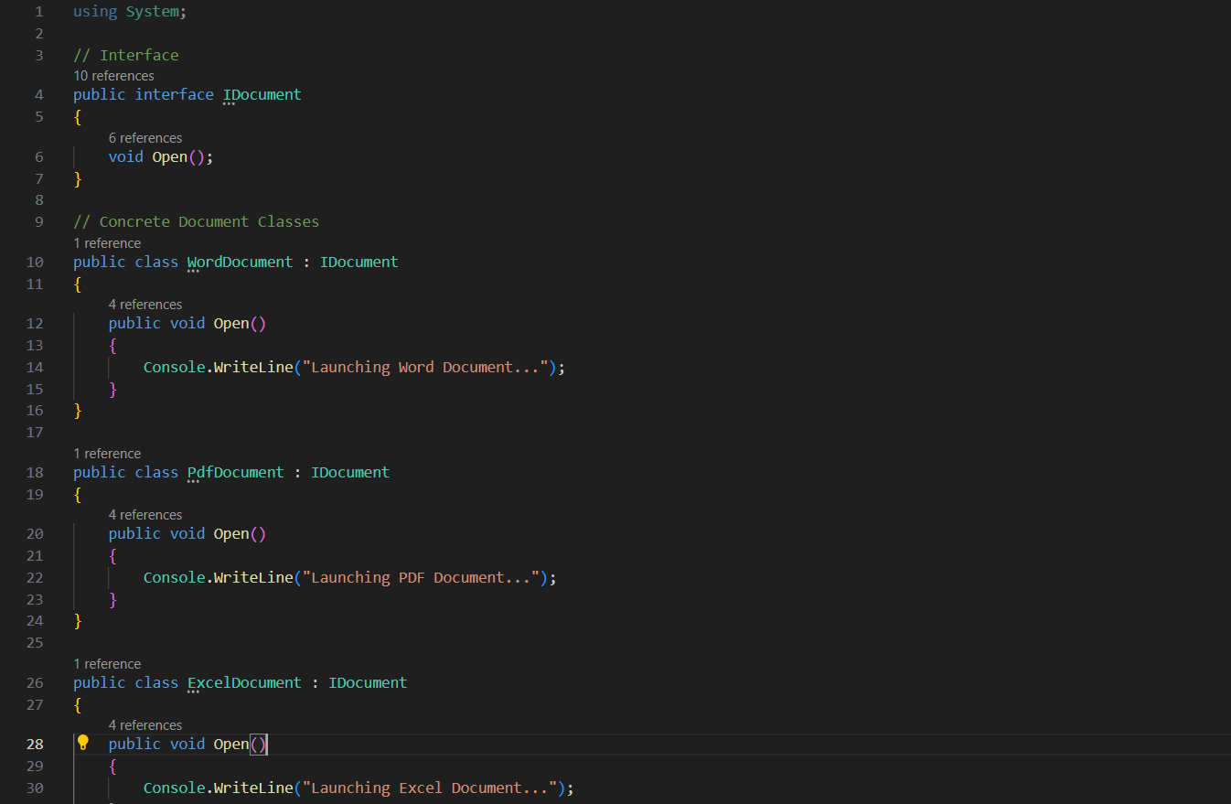

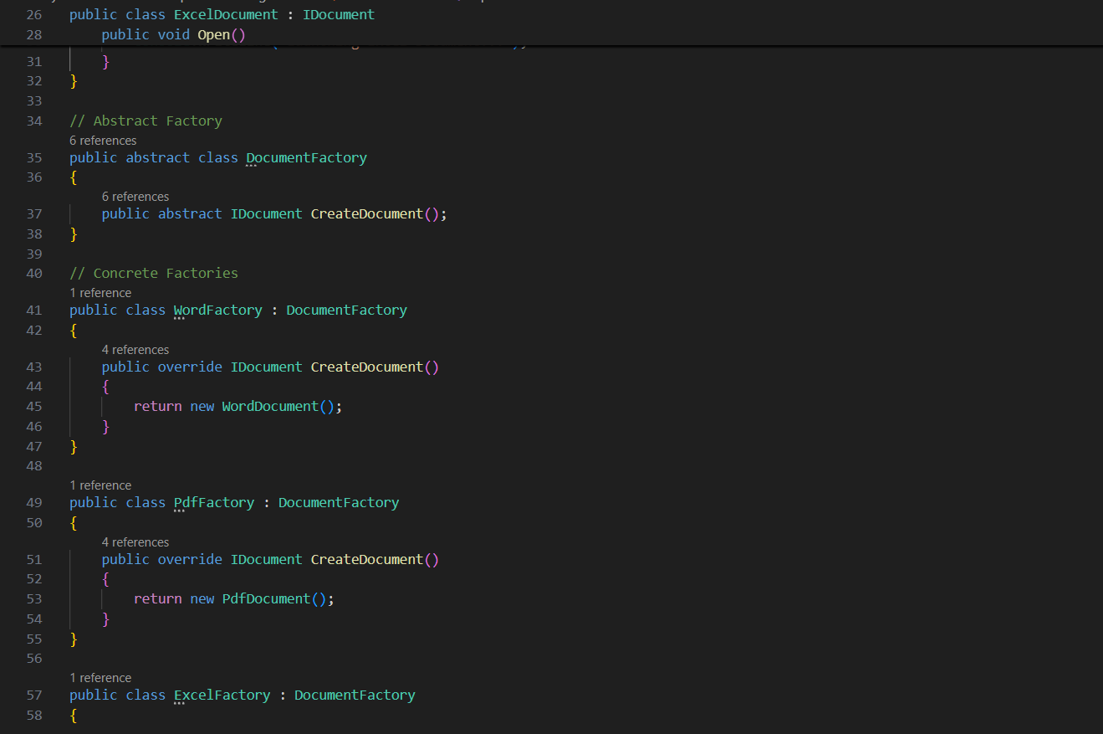

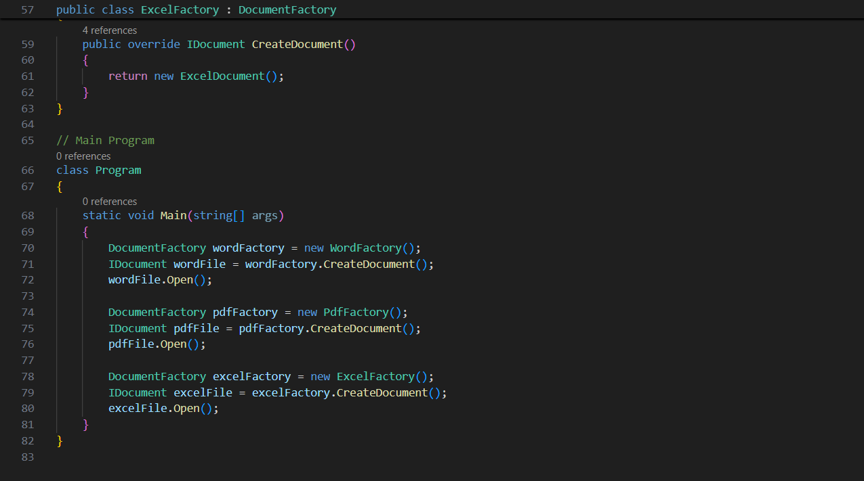

OUTPUT:

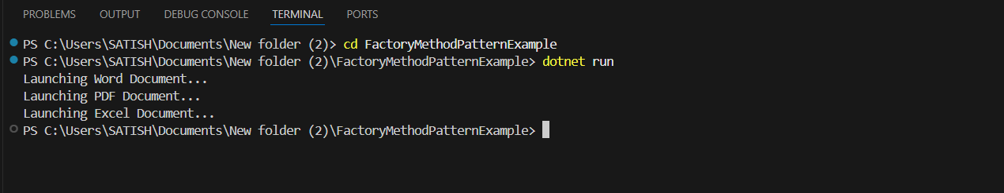

\***Algorithms_Data Structures**\*

Exercise 2: E-commerce Platform Search Function

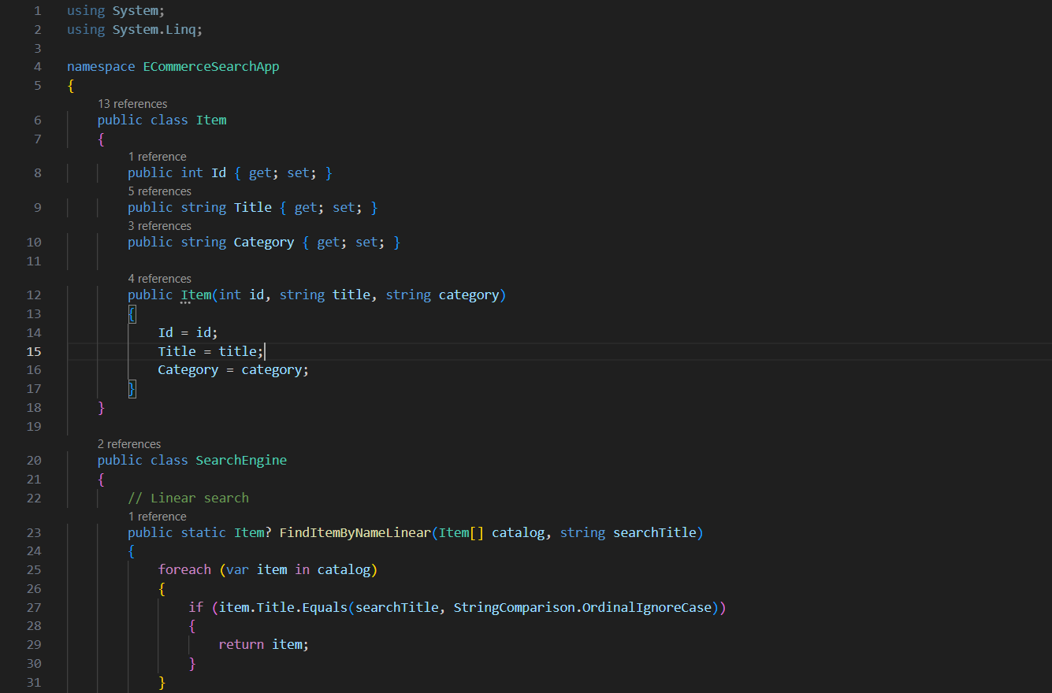CODE:

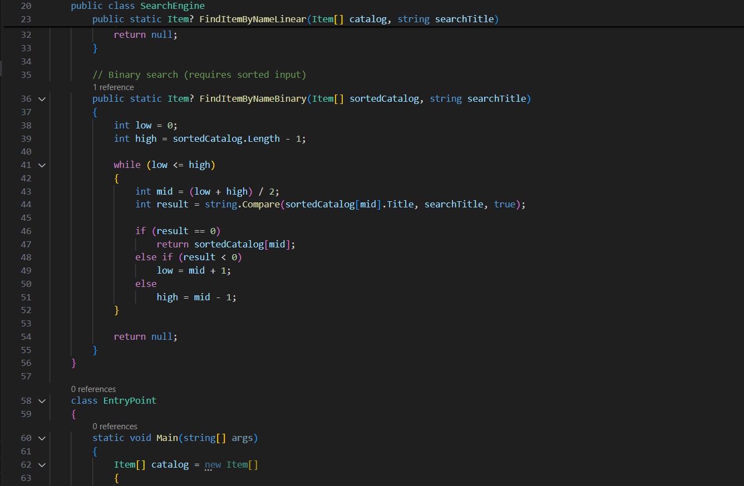

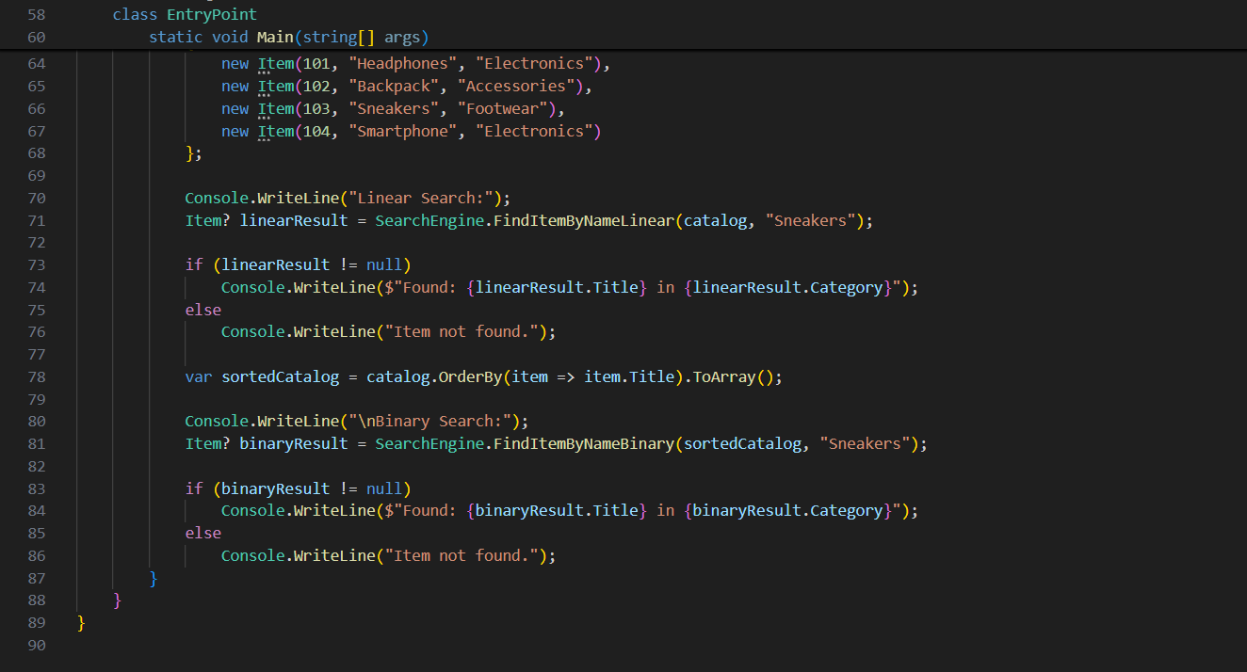

OUTPUT:

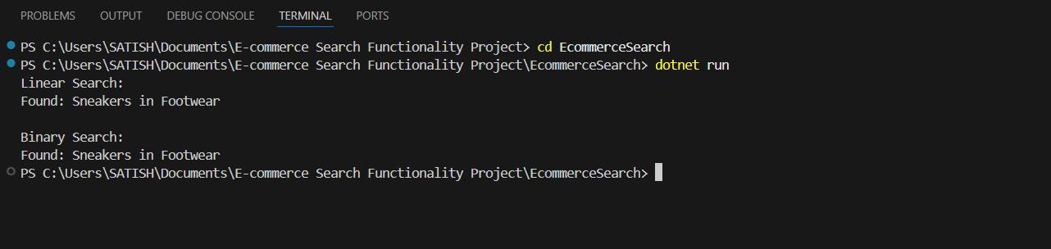

Exercise 7: Financial Forecasting

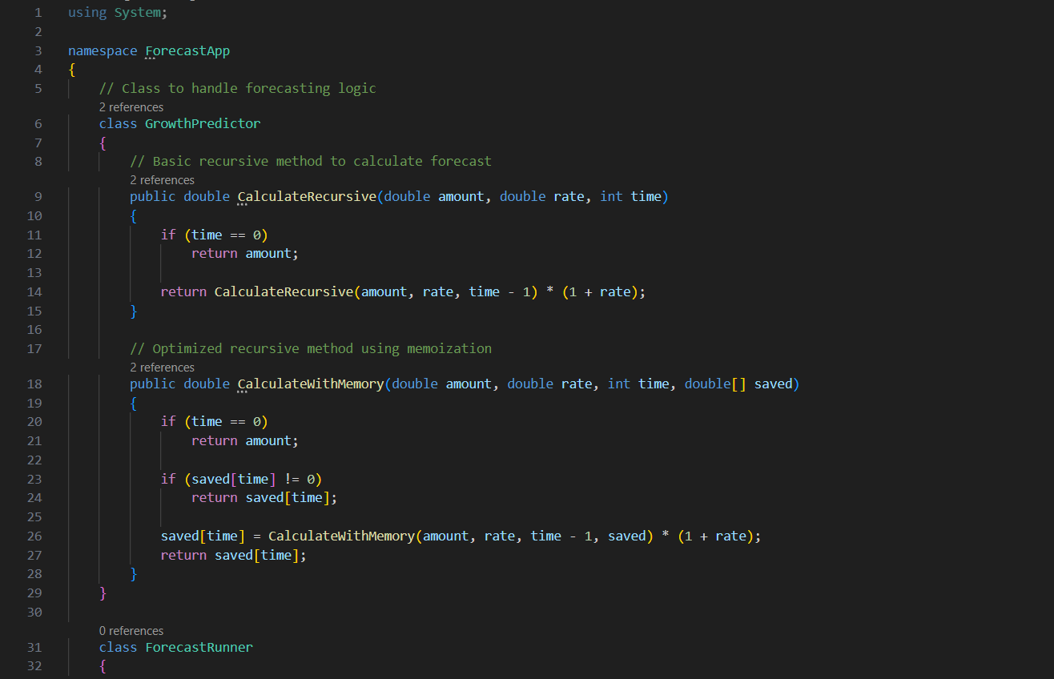CODE:

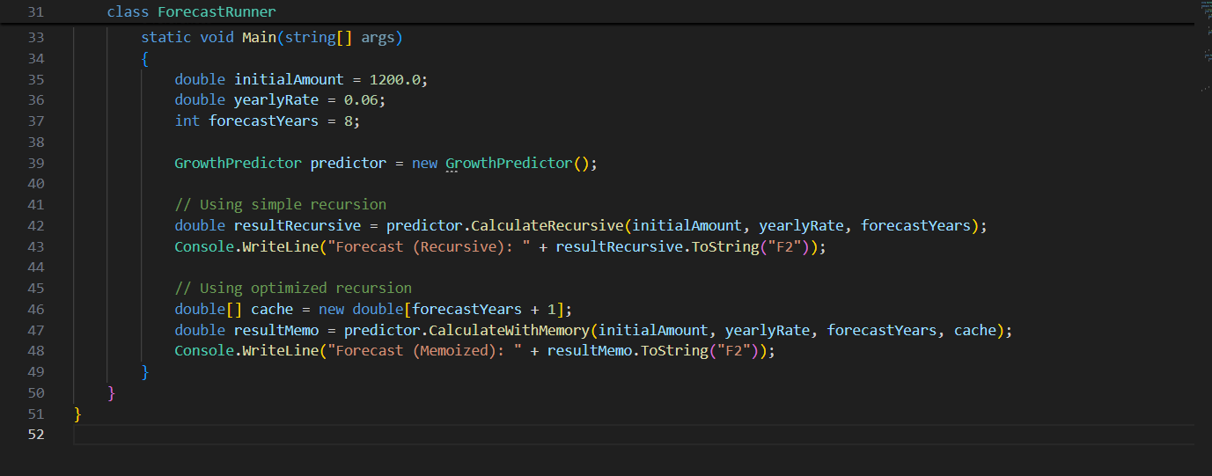

OUTPUT:

